Lab 3 Solution
Q1:
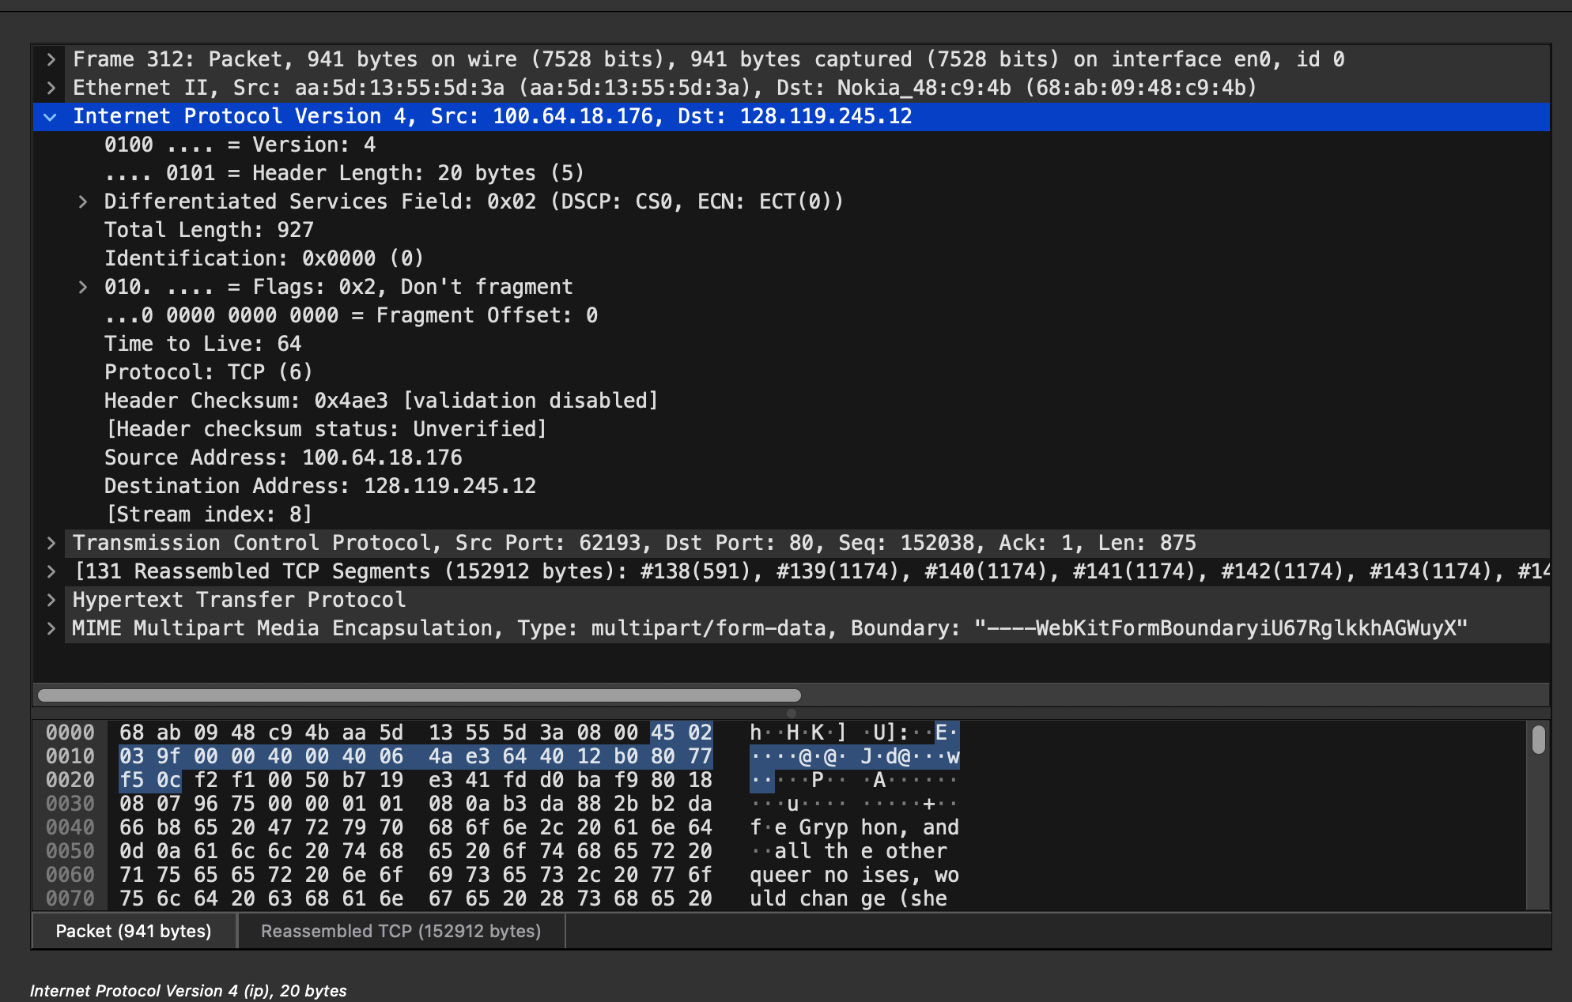
IP Address: 100.64.18.176
TCP Port: 62193

Q2:
Destination IP Address: 128.119.245.12
Destination Port: 80

Q3:
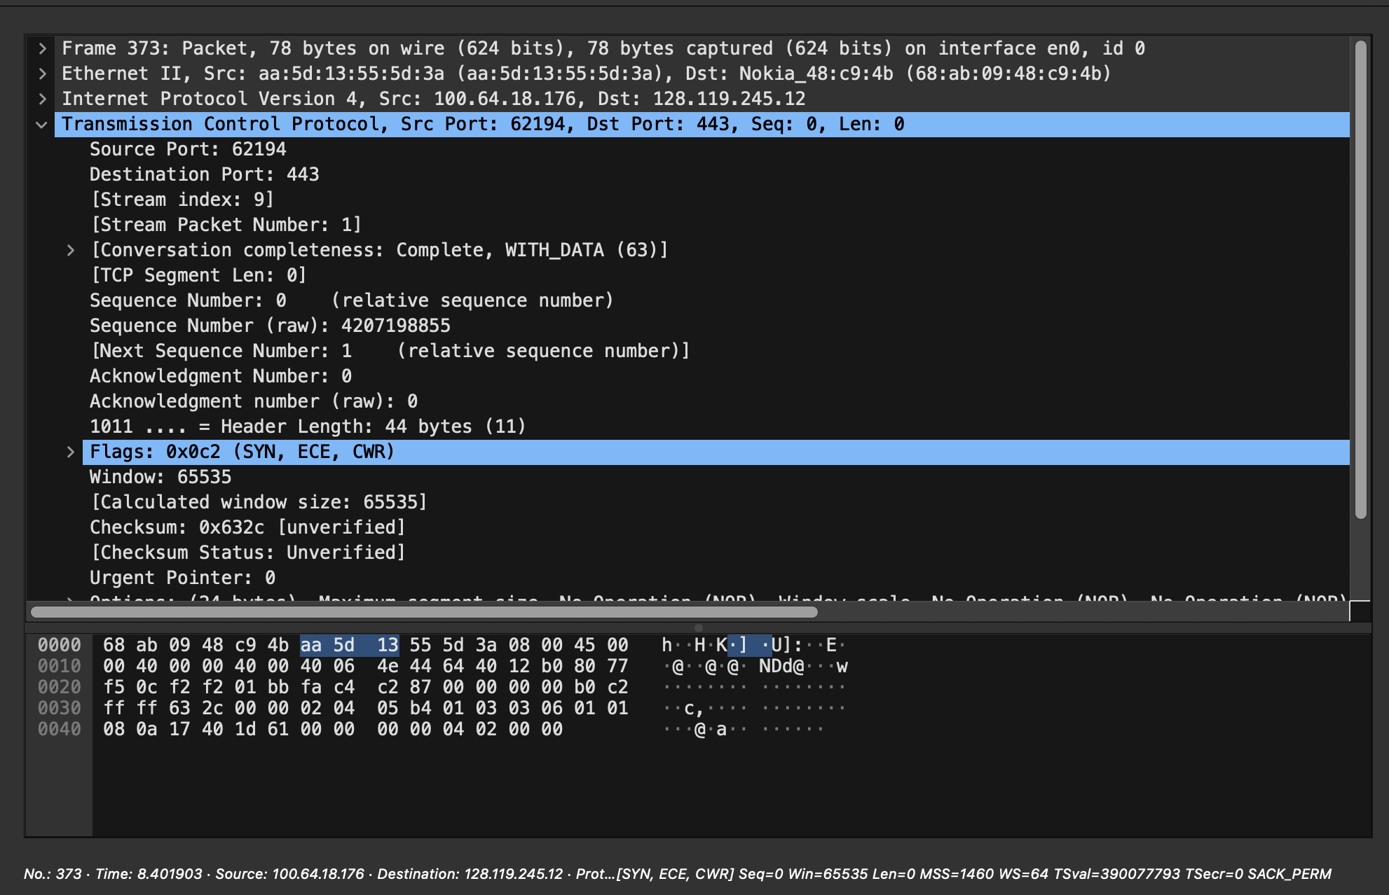
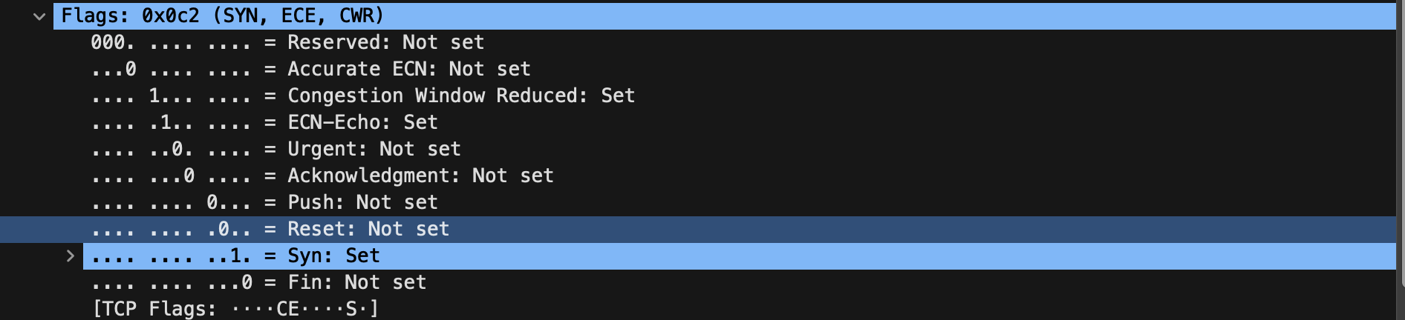
Sequence Number: 4207198855

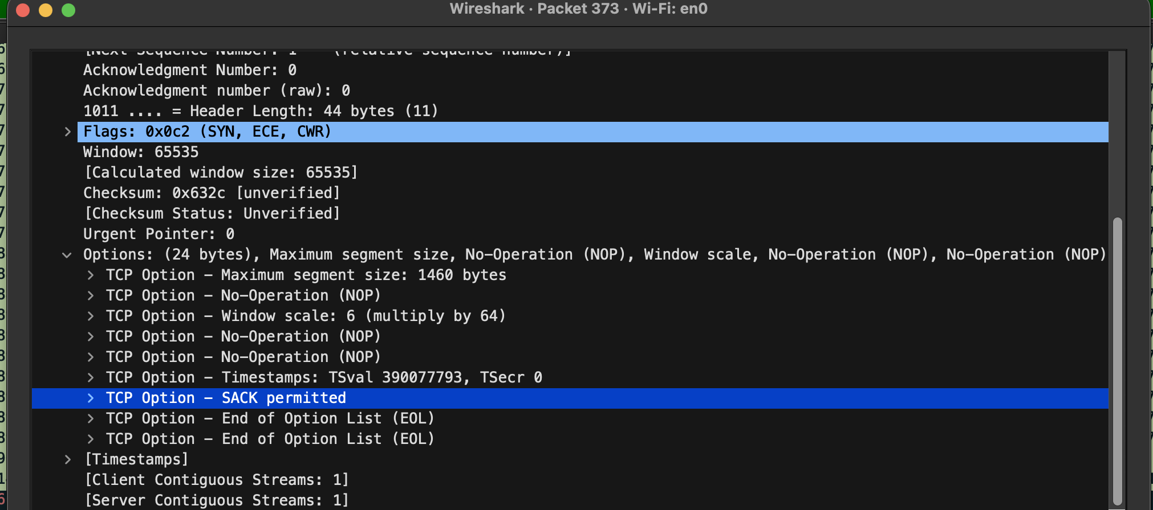
SACK permitted

Q4:
Sequence Number: 4207198856

Q5:
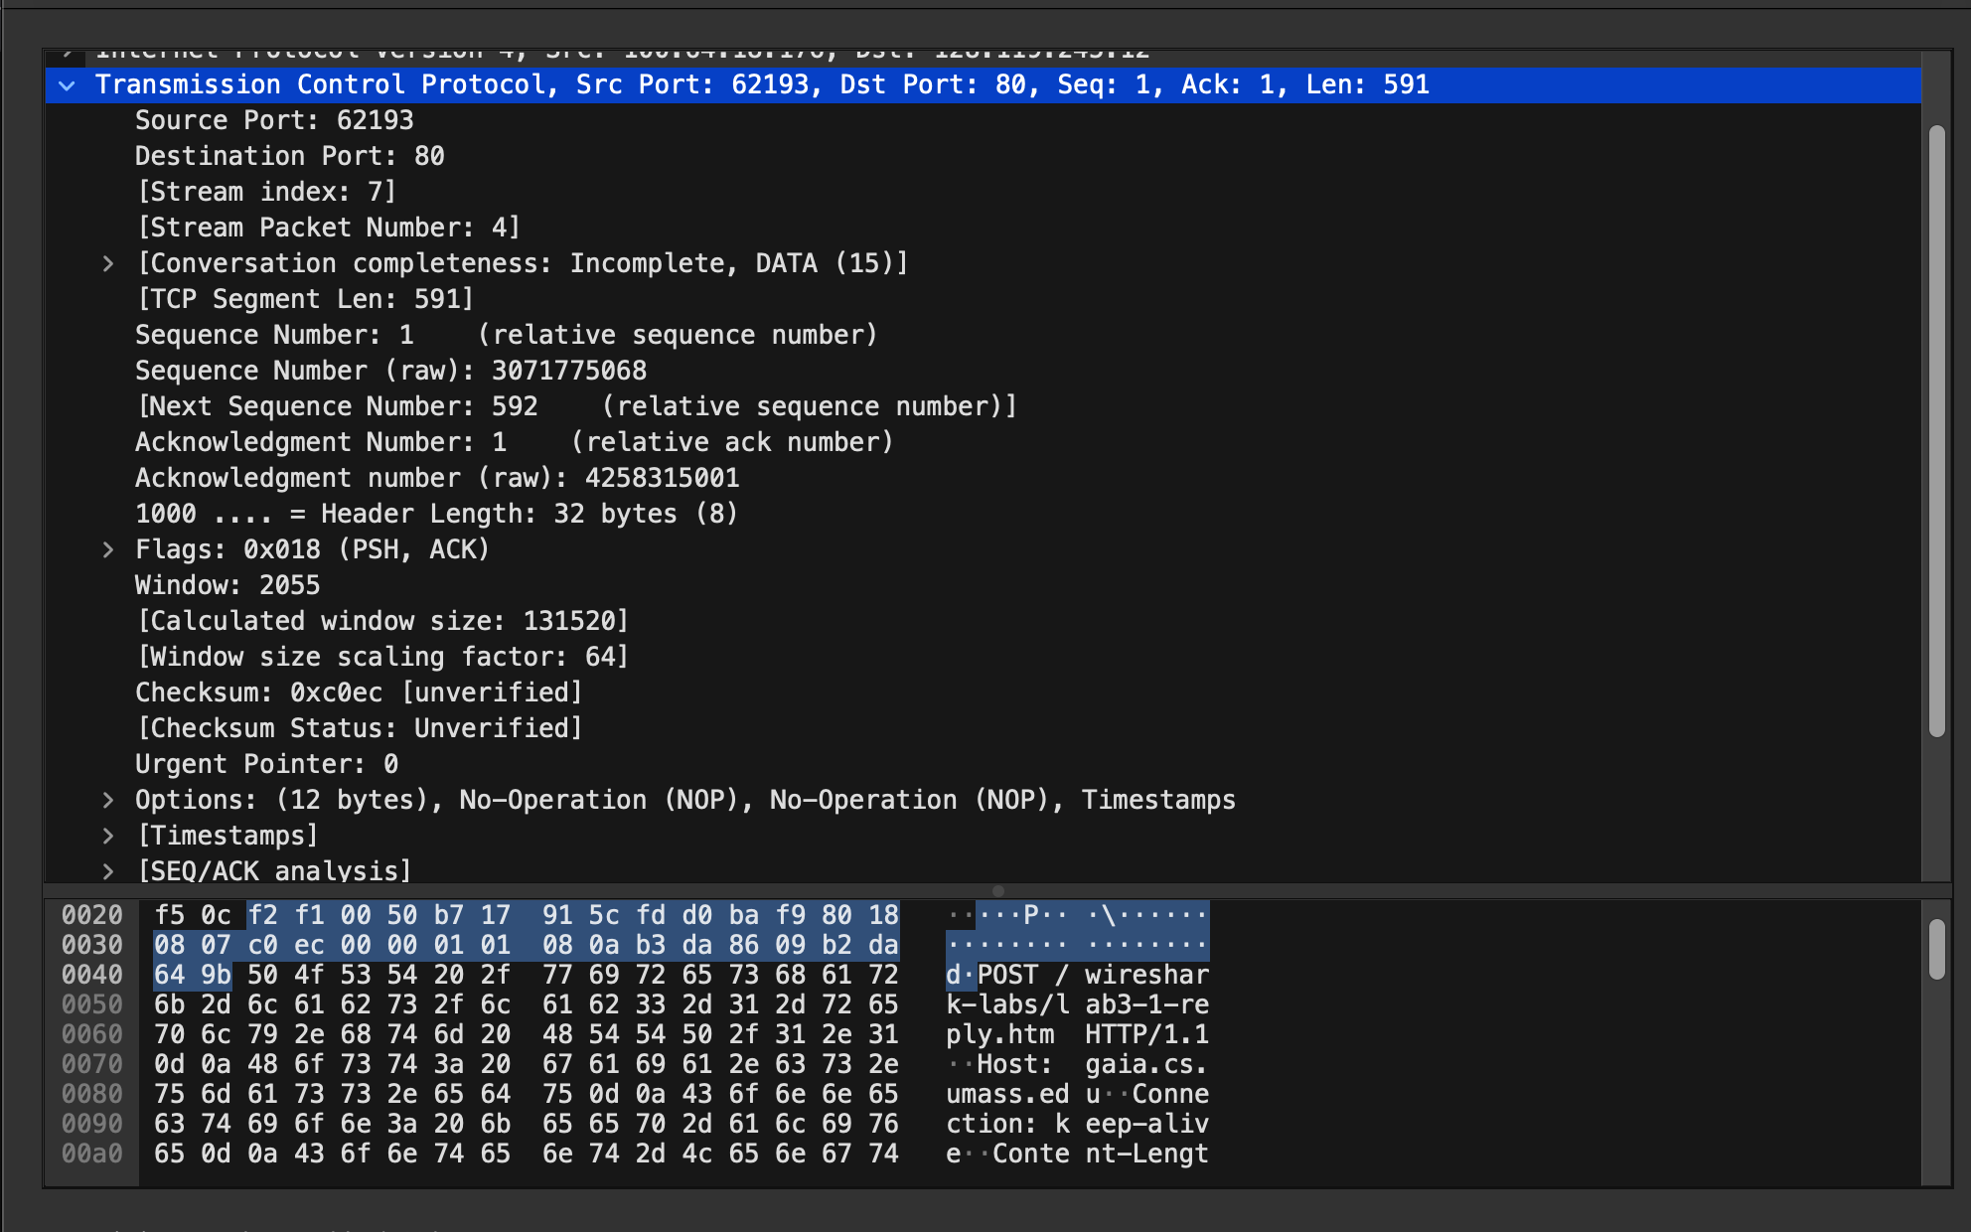
Sequence Number: 3071775068
The payload contains 591 bytes of data
No, the data did not fit into this single segment

Q6:
ACK Received Time for First Segment: 7.471139
RTT for the First Data-Containing Segment: RTT1= 7.471139 - 7.448726 = 0.022413
RTT for the Second Data-Carrying Segment: 0.022414
EstimatedRTT Calculation: using formula
alpha = 0.125
EstimatedRTT = 0.022413125 seconds
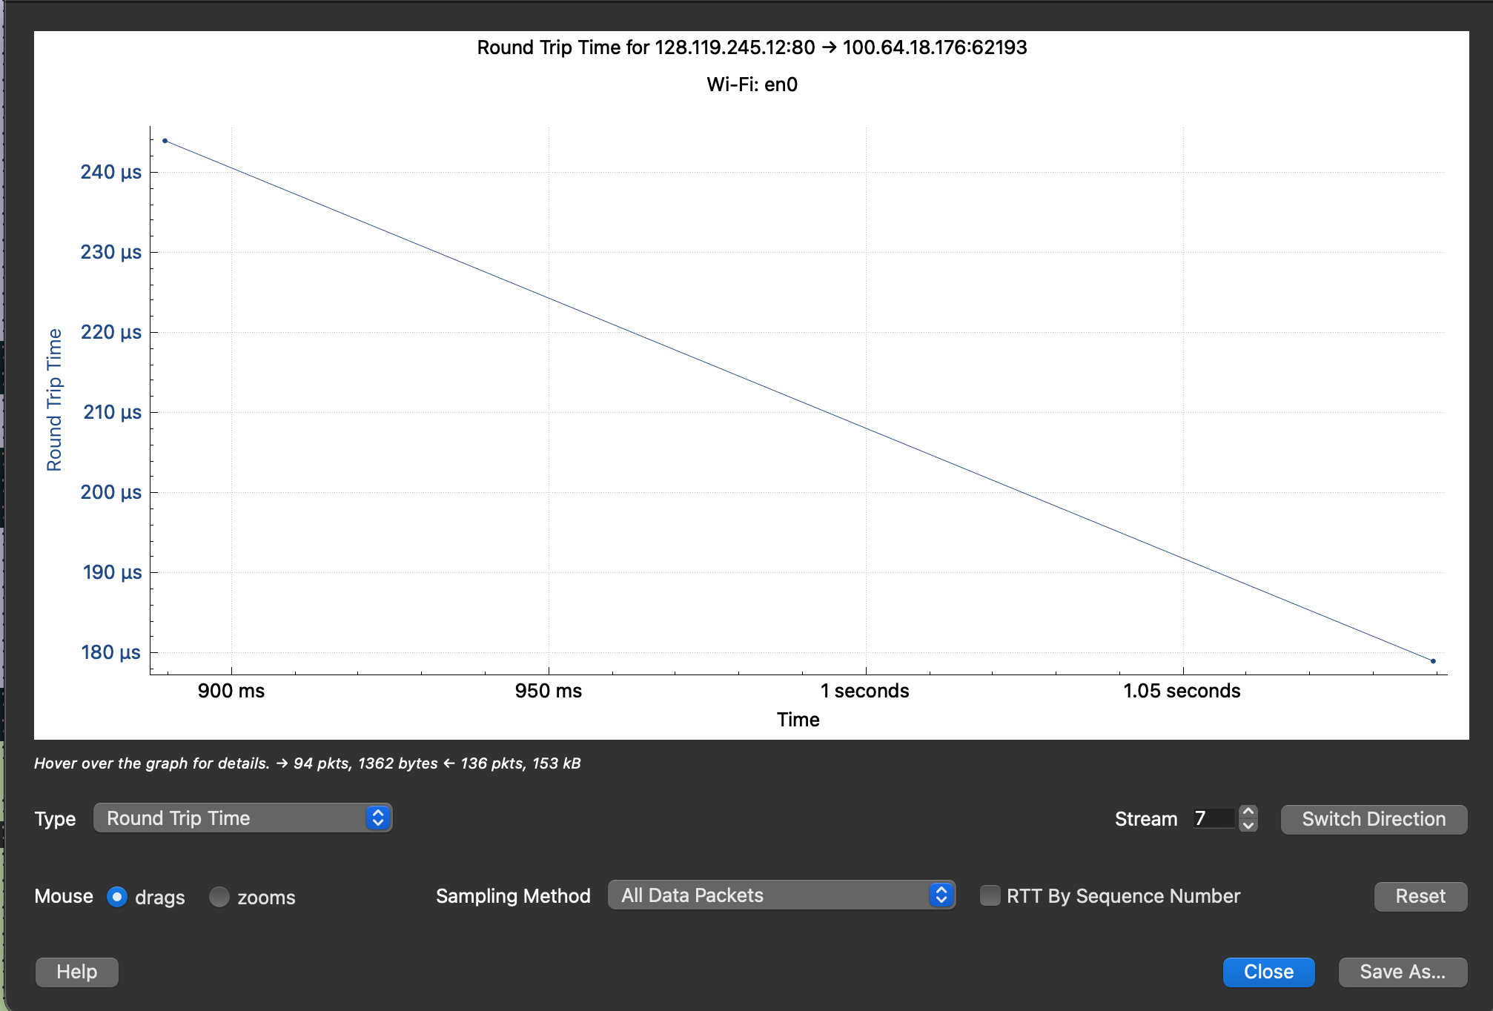

Q7:
Segment 1 (Frame 138): 657 bytes (591 bytes payload + 32 bytes TCP header + 20 bytes IP header + 14 bytes Ethernet).
TCP segment size, 623 bytes (591 payload + 32 header).
Segment 2: 1514 bytes.
Segment 3: 1514 bytes.
Segment 4: 1514 bytes.
Q8:
Window: 2055
Calculated window size 131520
No the sender is not throttled as the buffer size is much larger than the data being sent
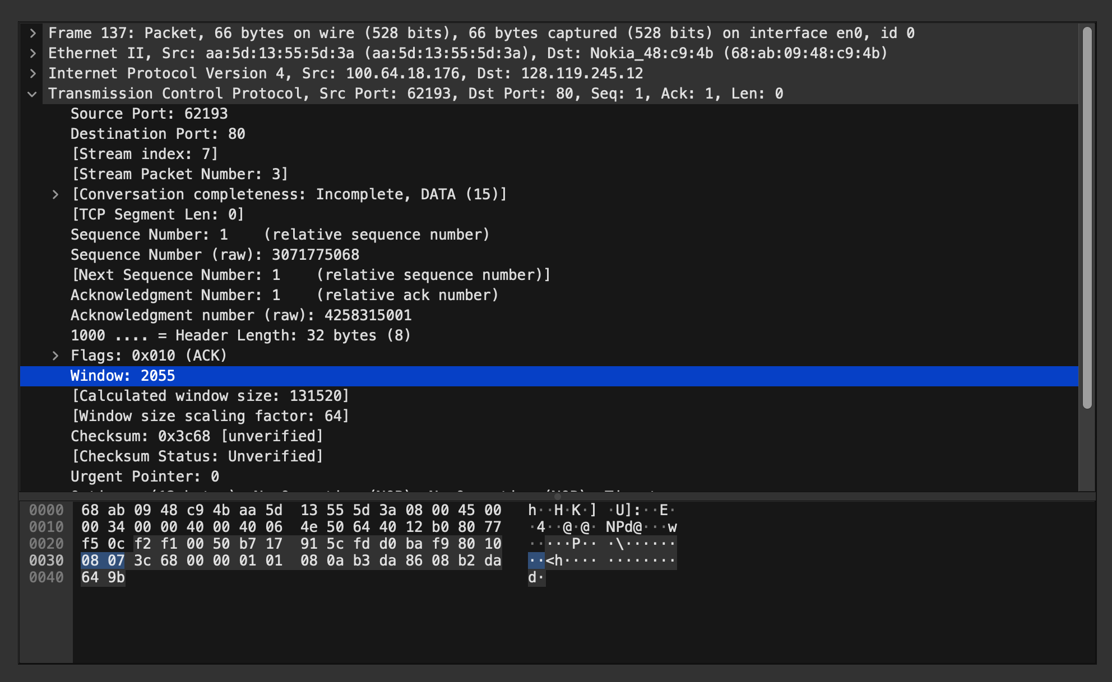

Q9:
Yes
Q10:
Typical Amount Acknowledged: 1174
Yes, you can identify cases of Delayed ACK as there is some major differences between bytes of different segments
Q11:
Throughput = Total bytes transferred / Total time taken
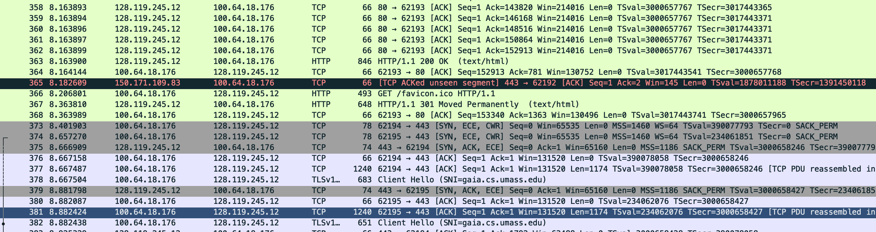
Frame 362 8.163899 - 7.448726
Throughput = 213,811 bytes/sec

Q12:
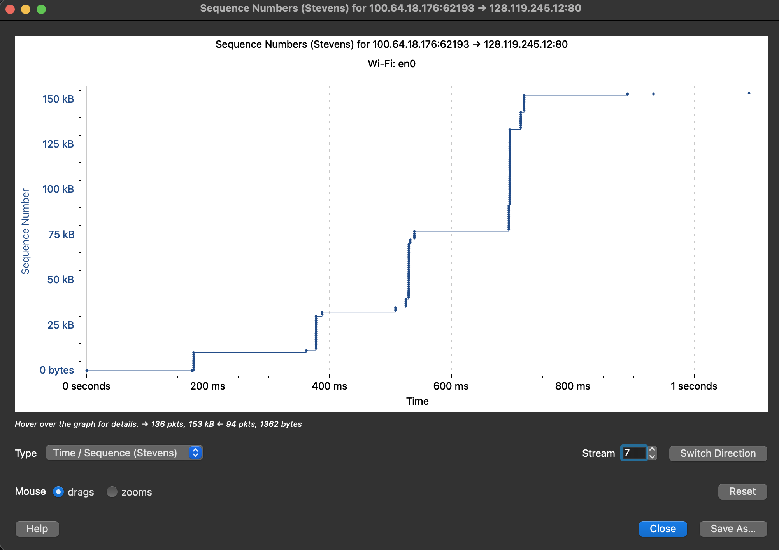
Looking at the Stevens graph, the dots show how the sequence numbers increase over time. I can see that the vertical groupsvfleets are getting taller every time they appear. This means the sender is sending way more data in each burst than it did before. This kind of fast, exponential growth is a clear sign that TCP is in the Slow Start phase. It’s basically the protocol testing the network to see how much data it can handle before it hits a limit.
Q13:
There is a clear pattern where the sender sends a bunch of data and then stops for a bit, creating those horizontal flat lines in the graph. These gaps represent the Round Trip Time (RTT). The sender has to wait for the ACKs to come back from the server before it’s allowed to send the next batch of packets. In my graph, this gap is roughly 150ms to 200ms, which is the time it takes for my data to reach the server and for the "all clear" signal to get back to my computer.

Q14:
In my trace, the connection stayed in Slow Start for the entire transfer. You can see this because each "step" in the graph gets taller than the one before it, showing that the sender is still doubling the number of packets it sends. Since the file was only 152KB, it finished before the network got crowded enough to switch to Congestion Avoidance. There were no horizontal flat spots or drops, so no packets were lost.

